UI Exception

Exercise #02

Flutter Developer Bootcamp

# **Purpose**

The purpose of this exercise is to create a simple error screen UI that displays a message icon, a title, and a message body. This UI can be used to inform users about errors or exceptional situations in a Flutter application..

# **Problem**

This exercise defines a screen for displaying error messages. It consists of an icon on the left and a title with descriptive text on the right. The layout is structured using Row and Column widgets, ensuring a clear presentation of information to the user.

# **How to Solve**

1. Checkout the workshop from Git Repo:

git clone -b <user-branch> <repo-URL>

2. Open the root folder inside VS Code

3. To build the app click the run option in the main method { }

4. Inside the Scaffold, there's a Row with two children:

* An Icon widget displaying a message icon.
* An Expanded widget containing a Column with two Text widgets.

5. The Text widgets display a title and Lorem Ipsum text, respectively.

# **You Will Achieve**

In the given code, you're creating a Flutter widget called Error Screen, which seems to be a screen for displaying error messages. Let's break down the components included in this code:

* Scaffold: The Scaffold widget is a basic structure for a screen in Flutter. It provides functionality for app bars, drawers, and snack bars.
* Row: A layout widget that arranges its children in a horizontal line.
* Icon: An icon widget from the Material Icons library. It displays the "message" icon.
* Expanded: This widget is used within a Row or Column to make its child expand to fill the available space along the main axis. In this case, it's used within a Row, so it will cause the Column that follows to take up the remaining horizontal space.
* Column: A layout widget that arranges its children in a vertical sequence. In this code, it's nested inside the Expanded widget.
* SizedBox: A box with a specified size. In this code, it's used to create a space with a height of 20 pixels above the text.
* Text: Displays a string of text. Two instances of Text widgets are used, one for the title and one for the content.

# **Screenshots**

## **Expected Output**

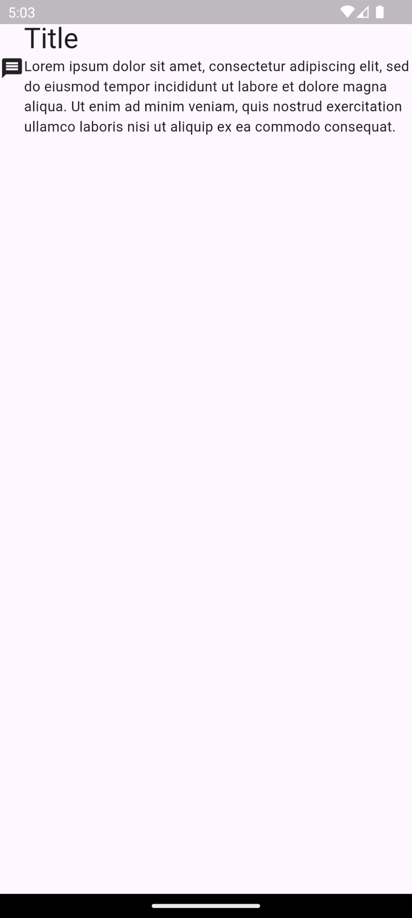

# **How to submit your Exercise**

Push your project back to the same git branch using command:

<command name>

# **Happy Coding!**